Georgia State Parks and Historic Sites
Weekly Summary

Crowds:
- For the third consecutive week, no site has had to temporarily limit day use access due to capacity. As visitation is increasing at the historic sites, the Dahlonega Gold Museum and Etowah Indian Mounds did reach building capacity several times this past week and limited access for a brief period.

Staffing issues:
- The Division has 17 part-time and full-time staff out due to COVID-19 related reasons. Since March, 94 employees have been tested for COVID-19, with 15 positives, 77 negatives, and 2 currently awaiting results. Several sites have multiple vacancies including High Falls and Skidaway.

Positives:
- Prior to construction beginning on the new visitor center at Skidaway Island State Park, Marketing installed a solar powered time lapse camera to capture the building from start to finish. See an example here. More to come as construction continues.

- Website statistics continue to be high. The Reservation pageviews were up 38% and total pageviews up 43%.

- Black Rock re-opened the Trading post in the campground for the weekend which was so busy on Saturday that hours were extended until 8 pm. A socially distanced- mask wearing staff meeting was held to inform staff all things COVID and all other updates.

- Construction started at Chattahoochee Bend on the handicap accessible paved trail up at Trailhead One. Large equipment has been brought into the park and is staged near the powerlines on the staff access roads.

- Chief Vann House met with GDOT concerning potential mitigation projects. Staff will be assisting with the design of four new interpretive panels, outdoor audio boxes, and artifact display cases. Staff is working with Archeology Unit and Judd Smith to revisit interpretation panels inside the cabin for possible upgrades. Friends group will assist with removal of artifacts and panels for temporary storage during restoration.

- Don Carter worked was a host site for Sweep the Hooch, a large shoreline cleanup on the Chattahoochee River. There were 33 volunteers and a total of 70+ bags of trash were removed from the park’s shoreline.

- As most sites are experiencing high occupancy, Elijah Clark had a 24% growth in revenue this August compared to last year.

- The construction of campsites 1-18 at Ft. McAllister is near completion with only two sites unfinished.

- The dog-friendly Yurt at Ft. Yargo has been completed and the debris cleanup, with the help of Ray and Jason, progressed well. Very excited that several positions have been filled including a new kiosk clerk, housekeeper and an office clerk starting soon.

- Jack Hill State Park hosted the Division’s annual Golf Course Meeting which was very beneficial.

- Assistant Manager Barrett at Kolomoki Mounds spent nearly 100 hrs. on RMU’s skid steer and rotary mulcher clearing numerous acres of invasive vegetation.

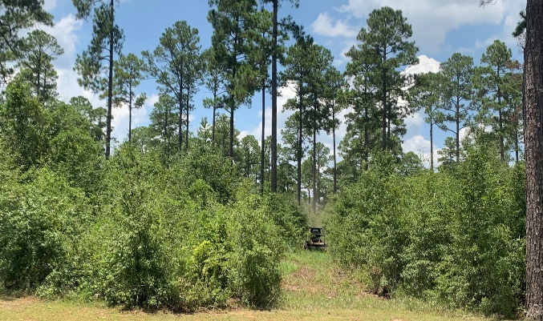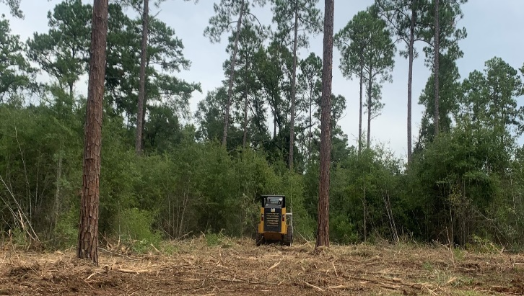

- The Beach renovation at Red Top Mountain will start just after Labor Day weekend. Cottage 10 and cottage 11 are close to being completed. Cottage 8 and cottage 9 have been demolished and are working on foundations.

- A group of Eagle Scouts have started a team of “Eagle Advocates” completing service projects at Reed Bingham. The group did a fantastic job of placing new signage around the park. They brought their own posts already cut to standard, their own tools, their own concrete, and really gave it their all. The park provided the water, and the rest was an Eagle Scout victory. Three employees (Lashley Wright, Kathyrn Patterson & Elizabeth Horne) attended ACA Kayak Training at Tallullah Gorge this past week.

- Phil Delestrez, Braxton Barden and a dedicated volunteer sprayed dense stands of kudzu along the roadways as well as in areas of difficult terrain at Amicalola Falls.

- Reynolds Mansion on Sapelo Island is now accepting reservations for as little as 8 people. After posting this announcement on Facebook- the first group booked in less than 15 minutes.

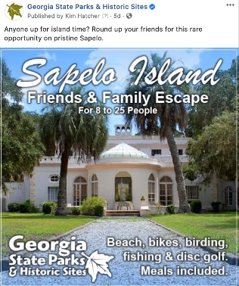

- A successful DNR CPR class was held at Skidaway Island with 9 participants from different parks. Also, HQ Retail and Marketing team were on site to assist with designing the upcoming retail space in the new Skidaway visitors center.
- Work continues on the creek ford project at Victoria Bryant. The contractors are scheduled to start pouring concrete on Monday 8/31/2020. We also acquired the skid steer with mulching head, to thin out some areas along the fairways at Highland Walk. Highland Walk was busy once again. Highland Walk’s three-day total in sales was $10,148.81.

- The new equestrian CXT bath house at Watson Mill Bridge opened for the first day on 8/28/2020.

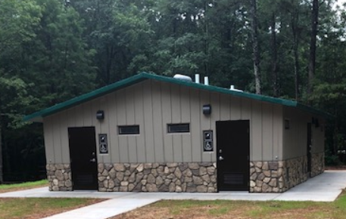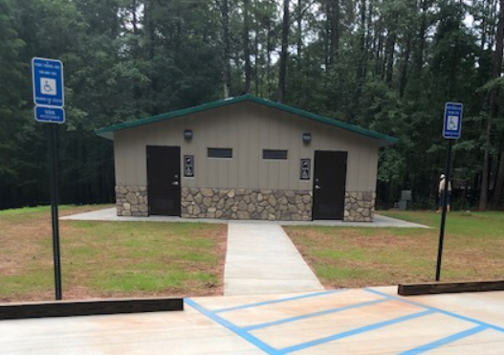

- The Training Manager met with WRD Game Management HQ Staff to provide an orientation and training on the DNR LMS.

- Tallulah Gorge hosted ACA Kayak Training this past week. DOT was able to remove barrels from the roadside and sign at the front entrance.

- Chief Naturalist attended portions of the Arkansas Virtual Interpretation Conference hosted on Zoom to gain ideas for hosting future training and meetings.

- Staff from the Wildlife Conservation Section, Georgia Forestry Commission and RMU participated in a North American Butterfly Association count at Smithgall Woods and Chattahoochee WMA/USFS land. Photo of a rare Diana Fritillary on Joe Pye weed.
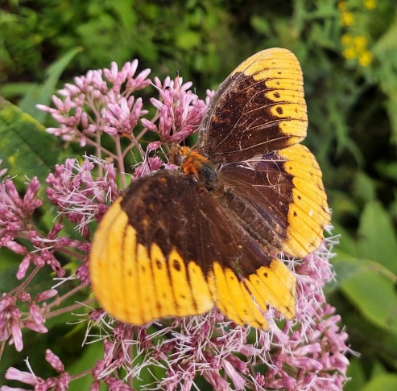

Challenges:
- Two housekeepers at Black Rock put in their notice in the same week which meant park management spent most of the last week cleaning cottages. These two resignations left the site with just one housekeeper. Interviews have been completed and background checks so these positions should be filled by mid-week.

- Park Rangers at A.H. Stephens assisted a horseback rider that fell from their horse onto hip and arm. The injuries were minor.

- Marketing continues to address issues with multiple social media pages at several parks this week including Chief Vann House and Magnolia Springs. These “non-official” pages can pull traffic from our official channels and be confusing to customers.

- The maintenance position at Chief Vann House is still vacant, leaving grounds maintenance to the Manager and Interpretive Ranger. Increasing number of guests have engaged staff into political conversations concerning national protests but staff has been trained on how to end the conversation politely but firmly while moving the conversation to providing site information.

- The dome on one of the Yurts at High Falls was damaged this past week when a large tree limb fell through the skylight while it was unoccupied. A park visitor suffered heat exhaustion on a trail this past weekend.

- This past weekend, Little White House had a subject committing criminal trespass, entering the site after hours. The subject did not access any building but did flee from law enforcement resulting in wrecking his motorcycle. Subject fled into the woods and there have been no arrest at this time.

- The well system at Stephen Foster had a failure during the afternoon of 8/27/20 resulting in a loss of water pressure in the park. Staff attempted repairs and called outside help to inspect and make repairs. Water was restored the morning of 8/28/20.

Financial Update:

Past Weekend:
This past weekend there was a 12% decrease to 63% in our overall occupancy for all reservables compared to the same weekend last year. Although – last year this weekend was the Labor Day Holiday. Camping decreased 11% and cottages dropped 7%. Yurts did see a significant improvement to 97% occupancy.

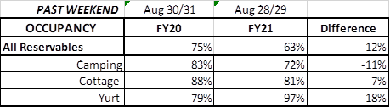

Upcoming Weekend:
For the upcoming weekend, we are already seeing a 33% increase in all reservables at 82% occupancy. Again – this upcoming weekend is Labor Day, while that was the prior weekend last year. Camping is currently at 92%, a 39% increase over last year and if you compare it to Labor Day last year, it is a 9% increase. Cottage occupancy is at 96% or a 34% increase. Yurt occupancy is showing an improvement of 8% to 96%.

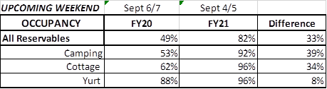

Revenue:
For FY21, July – August, park receipts have increased 8% or $485,000 over FY20 due to a very strong August.

From the month of August, Park Receipts increased 20% or $538,000 compared to last year. ParkPass revenue increased 37% or $137,000.

For this past week, August 24th – 30th : ParkPass increased 38% or $26,000. All overnight accommodations had a significant increase for the week. Camping revenue improved 32% or $69,000. Cottage revenue increased 31% or $51,000. And Yurt revenue improved 113% or $9,000. Golf once again had a very significant increase, improving 76% or $23,000.

Noteworthy, Historic Site admissions saw the first increase since the COVID pandemic began and improved 5% or 1,500 in comparison to last year.

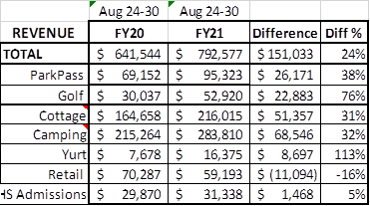

For the month of August, forty-two (42) sites saw an overall revenue increase and thirty-three (33) saw a 10% or higher revenue growth. Site specific financial results for August include:

- Congratulations to the three (3) sites who had a $45,810 or greater revenue increase for August compared to last fiscal year. Vogel which saw a $ 71,445 or 36% increase, Richard Russell which saw a $ 51,292 or 49% increase, and Cloudland which saw a $ 45,810 or 37% increase compared to FY2020.

- Congratulations to the five (5) sites who had a percentage increase of 53% or greater for August as compared to last fiscal year. Smithgall Woods which saw a 144% or $ 33,592 increase, Hamburg which saw a 99% or $ 8,148 increase, Chattahoochee Bend which saw 56% or $9,687 increase, Fort King George which saw 55% or $2,552 increase, and Victoria Bryant which saw a 53% or $28,690.

